**Challenge 11**

[www.pythonchallenge.com/pc/return/5808.html](http://www.pythonchallenge.com/pc/return/5808.html)

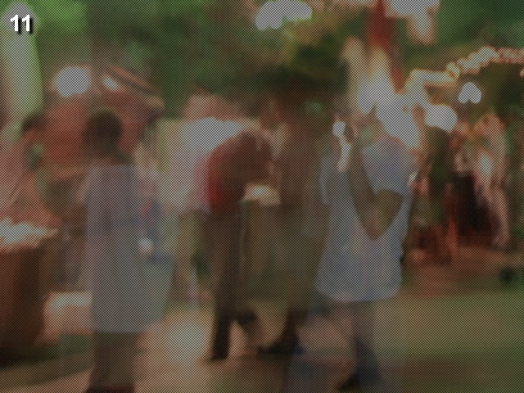

This picture is a fuzzy looking maybe market scene. The title is odd even. Clicking on it didn’t do anything. The page source doesn’t seem to have any clues. So, I tried taking every other pixel. Finally taking the evens faintly spelled out evil.

Plugging that into the url instead of 5808 goes to the next challenge.